 Maintaining Emergency Contacts

Click on the “Personal Details” tile
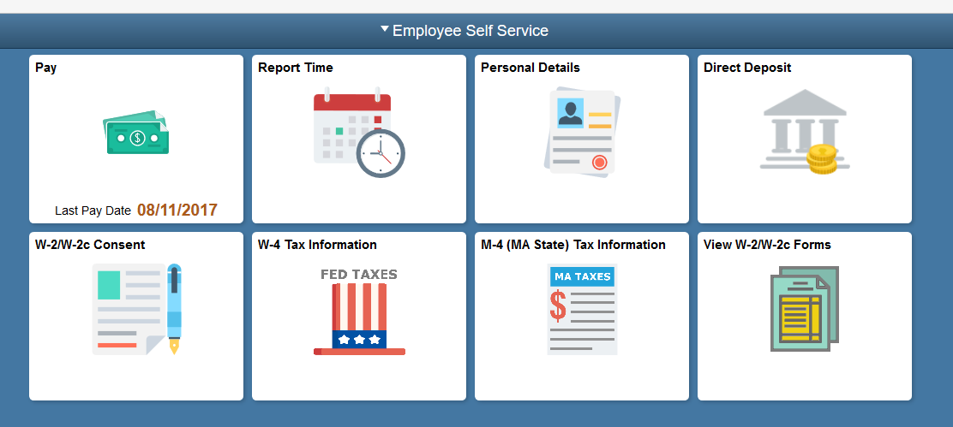
Click the Emergency Contacts link.
Use the Emergency Contacts page to view, add, update, and delete emergency contacts.
You can modify existing rows by clicking on the existing contact, updating the fields and clicking the Save button.
To add another emergency contact,

Click the Plus sign icon
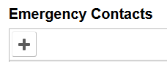
Complete the contact information

Click the Save button.

Review the change you've made.
Congratulations! You've successfully added an emergency contact to your personal information.
End of Procedure.

